Assignment 2

Name: Michael Black
Student Number: 221402063
Date: 28/08/2023

I declare that this is my own, original work.

Signature: _________________

Implementation Details

Stopping Conditions: 5000 iterations
Initial Weight Ranges: 0-1
Training Set size: 10000
Test Set size: 2000
How was test set selected? 2000 of the 12000 inputs were used that was not part of the training set.
Values for η investigated: 0.1 to 0.00001
Activation functions: Sigmoid
Number of hidden neurons: 10

The network consists of 16 inputs with one hidden layer of 10 neurons, and 7 output neurons. Each hidden layer neuron has 16 inputs with an associated weight as well as a bias. Therefore, there are a total of 16x10=160 weights for the inputs as well as 10 bias weights totaling 170 input to hidden weights. The output of the hidden neurons is the Sigmoid of the weighted sum of all the inputs plus the bias weight. The same applies for the output layer which also uses the Sigmoid function. The hidden to output weights total to 80 including the bias weights. The bean type is determined by observing the neuron that has the highest output value, or that fires the most. Each neuron is associated with a specific bean type.

Results

Number of iterations (typically): 5000
Best η value: 0.001
Sum Squared Error (SSE) on Training Set: 48
SSE on Test Set:
Percentage correctly classified on Training Set: 99.91
Percentage correctly classified on Test Set: 99.75
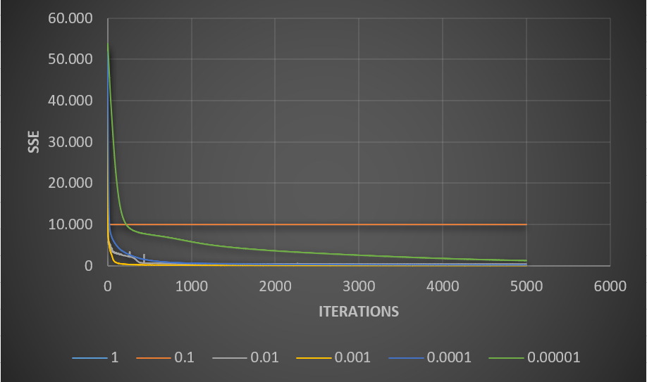

Figure 1: SSE vs iterations for various values of η

Investigated Techniques

Additional Techniques Investigated:

Technique | Percentage Correct on Training Set | Percentage Correct on Test Set
Weight initialization
Adaptive learning rate
Noise Injection

Figure 2: SSE vs iterations for the three techniques

Results on patterns in Demo.csv:

1 | DERMASON | 11 | SEKER | 21 | DERMASON | 31 | BARBUNYA | 41 | DERMASON
2 | HOROZ | 12 | BARBUNYA | 22 | HOROZ | 32 | BOMBAY | 42 | SEKER
3 | CALI | 13 | HOROZ | 23 | SIRA | 33 | SIRA | 43 | HOROZ
4 | BARBUNYA | 14 | DERMASON | 24 | SIRA | 34 | CALI | 44 | SIRA
5 | BARBUNYA | 15 | DERMASON | 25 | SIRA | 35 | HOROZ | 45 | SIRA
6 | SIRA | 16 | DERMASON | 26 | DERMASON | 36 | DERMASON | 46 | SIRA
7 | SIRA | 17 | SIRA | 27 | BARBUNYA | 37 | DERMASON | 47 | DERMASON
8 | BARBUNYA | 18 | SEKER | 28 | SIRA | 38 | DERMASON | 48 | HOROZ
9 | SIRA | 19 | DERMASON | 29 | CALI | 39 | DERMASON | 49 | SIRA
10 | SEKER | 20 | SIRA | 30 | DERMASON | 40 | SIRA | 50 | DERMASON

Observations

Batch learning proved to be far superior to stochastic learning in this case. For the speed of iterations was much faster since the weights were only updated once per iteration instead of once per pattern. This drastically reduced the time it took to train, and the accuracy improved to nearly 100 percent. The best error received with stochastic learning was 75% for 1000 iterations.

Data preprocessing was vital in order for the network to perform properly. The input values had to be scaled appropriately so as not to saturate the activation function. Without scaling the input values the network simply wouldn’t learn and the output would always be the same. The learning rate also caused convergence issues if it was too high. The SSE would not decrease beyond a certain number of iterations. This is probably due to the weights jumping around a local minimum. Since the gradient is too large, the weight cannot be adjusted appropriately to reach this local minimum.

